Đề 1:

* Q6:

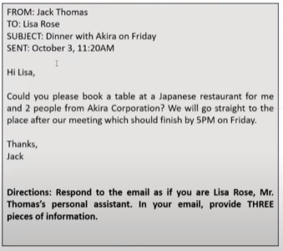

Dear Mr. Thomas,

I am writing in response to your email dated October 3rd about your dinner with Akira on Friday.

I have booked a table for 3 people at 6PM at Sumo restaurant. This restaurant **is located at** 22 Spring Street. In addition, the reservation is made under the name of Mr.Thomas.

Please let me know if you need anything else.

Best regards,

Lisa Rose

* Q7:

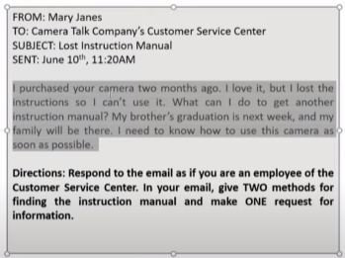

Dear Mrs. Janes,

My name is Rony and I am an employee at Camera Talk Company’s Customer Service Center. I am writing in response to your email dated June 10th about your lost instruction manual.

There are 2 methods to get another instructional manual. First, you can download it instantly on our website. Alternatively, we would send you a new manual by post. If you choose (to receive a new manual by post)/(the latter – phương án thứ 2), could you please let us know your address?

We are looking forward to hearing from you soon.

Best regards,

Rony

* Q8:

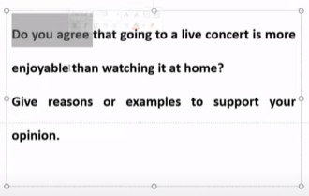

Mở bài: nêu ra quan điểm của bản thân, tuy nhiên nên giới thiệu khái quát về bối cảnh liên quan đến đề bài.

* Answer:

Some people say that attending a live concert (= to go a concert) is more preferable (= more attractive) to watching it at home. **Personally, I disagree with this statement and there are some reasons to support my opinion.**

To begin with (=First), watching a live concert at home helps me save time (=is time-saving). This is because I don’t have to spend time travelling to the place and parking my car. All I have to do is turn on the television, sit back and enjoy myself. Last year, I went to a live concert. It took me 1 hour to get to the stadium where the concert was held. In addition, it was very hard to find a place to park so I wasted another hour. Finally, when the concert began, I was too tired to enjoy it.

Second, watching a live performance at home helps me save money. This is because I don’t have to pay for tickets and parking. I already own a television so it doesn’t cost me anything to watch concerts at home. I have a friend who is a big fan of a Korean boyband. She attended all of the live concerts of this band. As a result, she is always broke and often borrows money from her friends to pay for her rent. I think this is not a good way to spend money.

Third, watching live events at home is more comfortable. I can wear any clothes what I want. I can sit whenever I want. However, I cannot do those things if I attend these events. In the past, every time I went to a live concert, I had to stand during the whole performance because all the good seats with good views had been taken. Now, because I stay at home, I don’t have to stand anymore.

In conclusion, I disagree that going to a live concert is more fun than watching at home. However, choosing to do the former or latter will depend on each person’s personality and preference.